Report on "Awareness Session (15th July 2026)"

The Awareness Session was held at CIPET:IPT Ahmedabad regarding Student Startup and Innovation Policy (SSIP 2.0) initiated by the Government of Gujarat. Approximately 92 students from various programs including Diploma & Post Graduation Diploma were present at the event. During the event, the Ms. Priyanka from CIPET:IPT, Ahmedabad delivered a motivational speech focusing on the Student Startup and Innovation Policy (SSIP 2.0) initiated by the Government of Gujarat. The discussion centered around enlightening students about this policy and its implications, encouraging them to explore innovative ideas for potential startups. The gathering provided an insightful platform for students to gain valuable knowledge and perspectives on entrepreneurship and innovation, fostering an atmosphere of creativity and forward thinking.

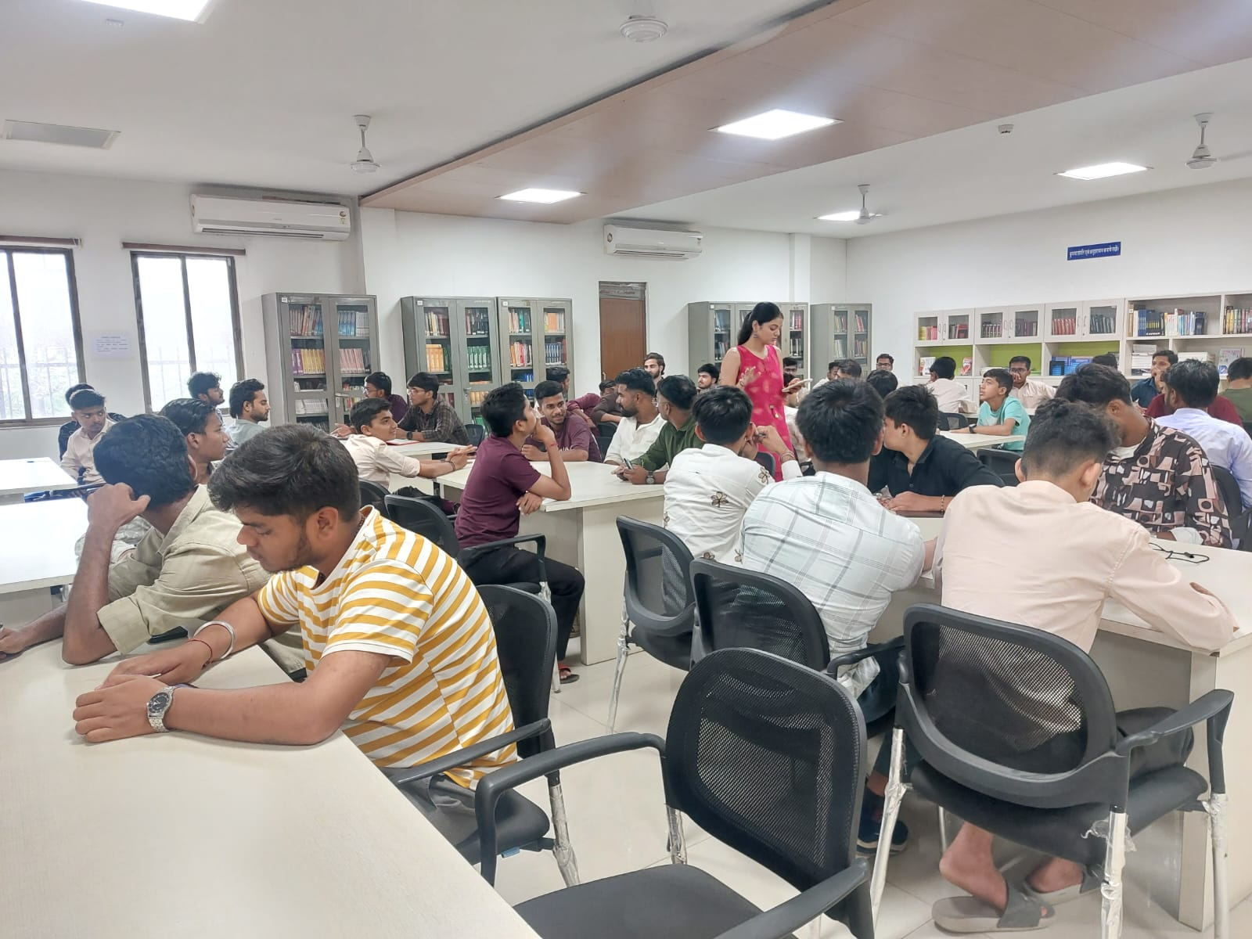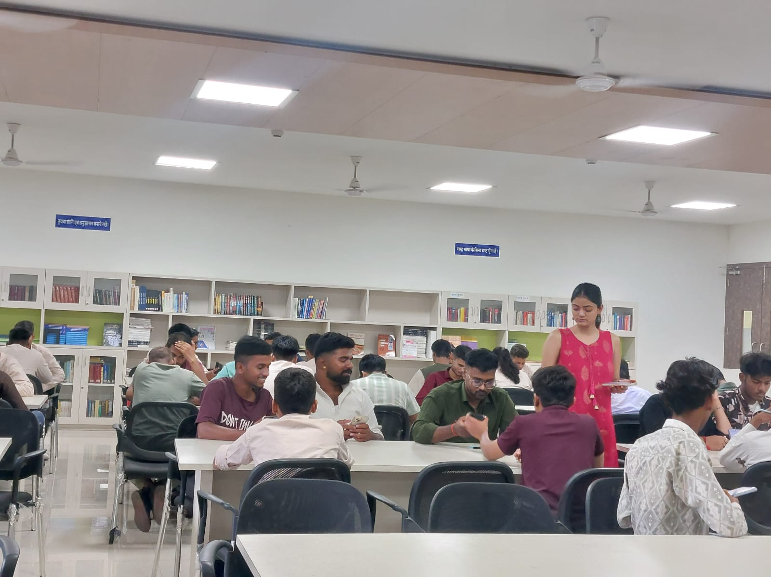

……………. END OF REPORT…………….

